|  |  |
| --- | --- |
| Assignment Date | 28 September 2022 |
| Student Name | DHARSANA R |
| Student Roll Number | 953619104010 |
| Maximum Marks | 2 Marks |

**IBM ASSIGNMENT -2**

**PHARMA SALES DASHBOARD**

**Task 1: Sales By Customer**

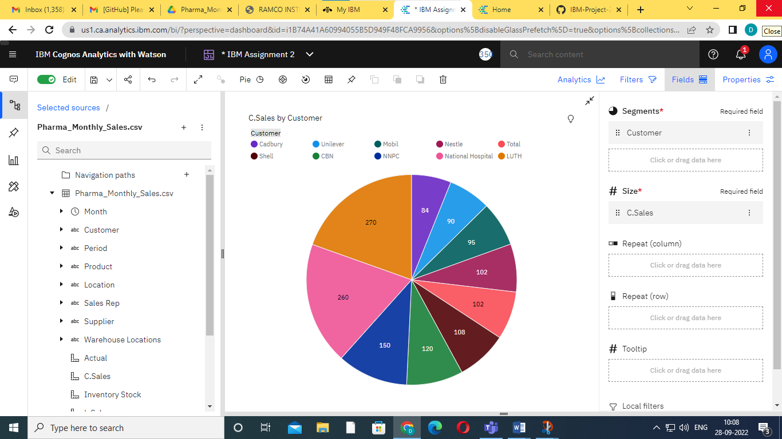

**Task 2: Sales By Location**

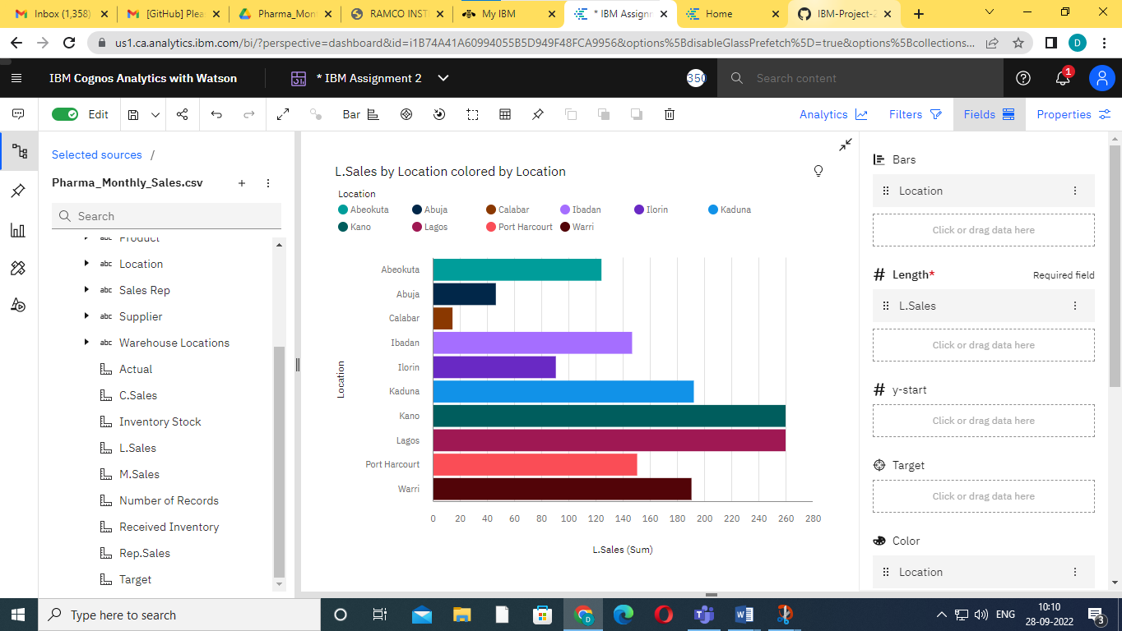

**Task 3: Sales By Sales Representative**

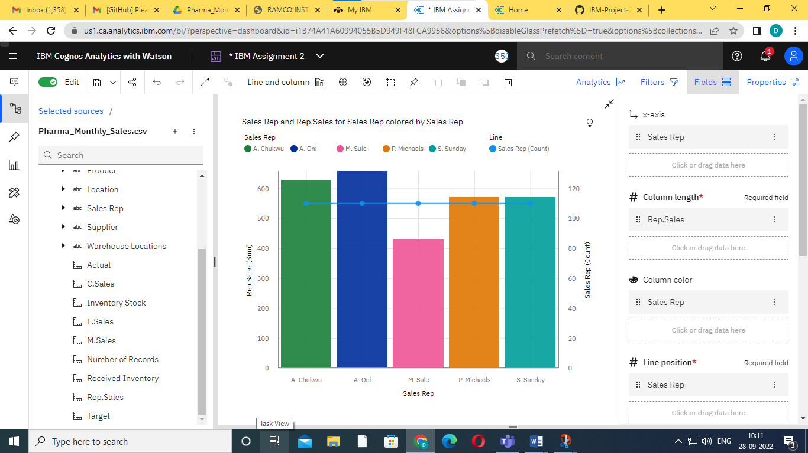

**Task 4: Received Inventory From Supplier**

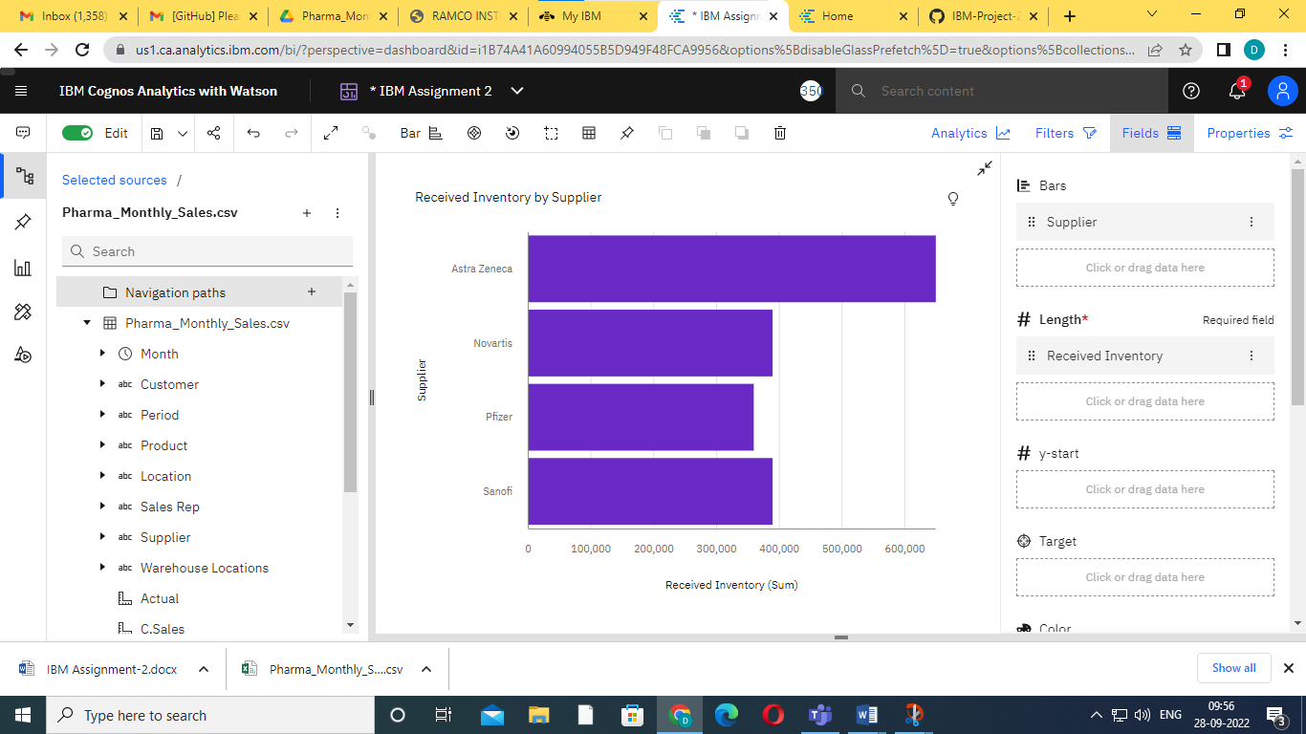

**Task 5: Inventory Stock for Warehouse Locations**

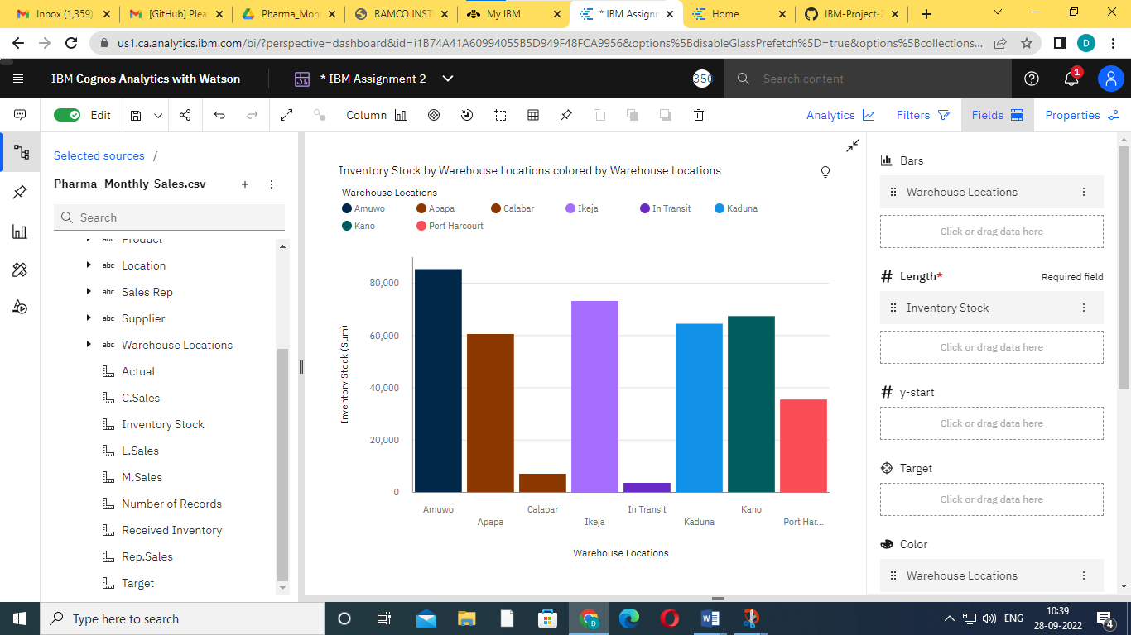

**Task 6: Sales Trend**

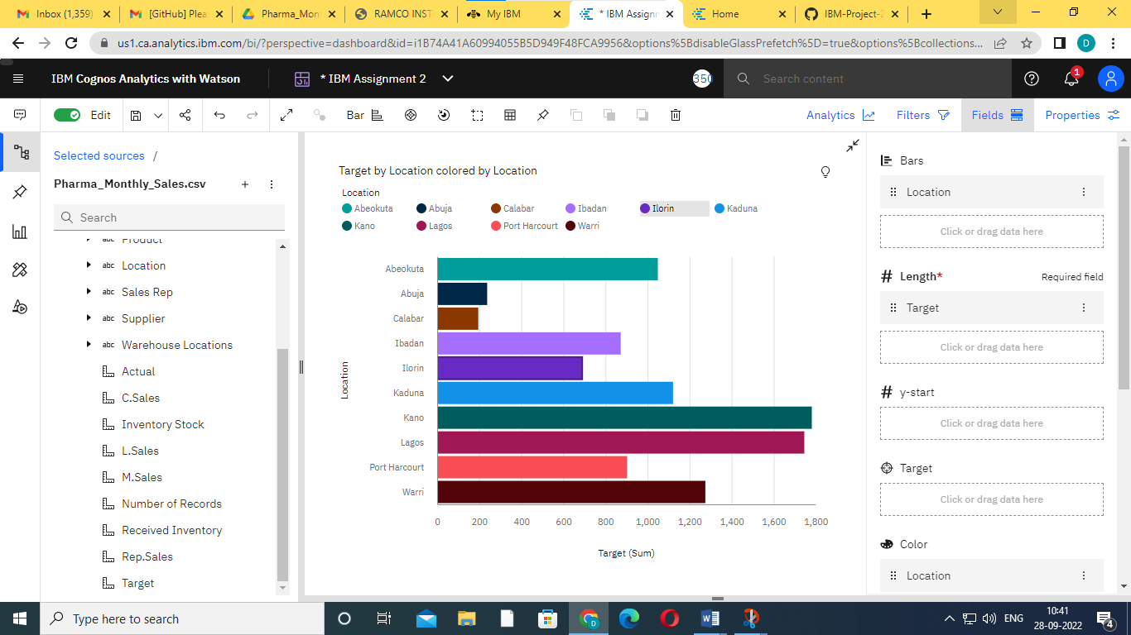

**Task 7: Monthly Sales**

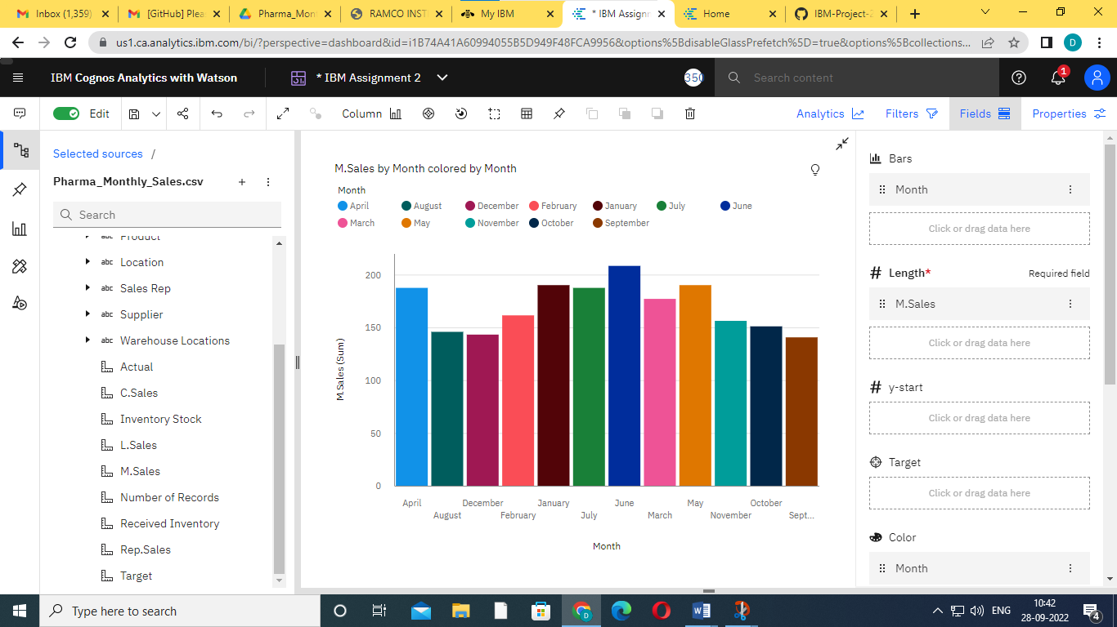

**Task 8: Actual and Received Inventory by Month**

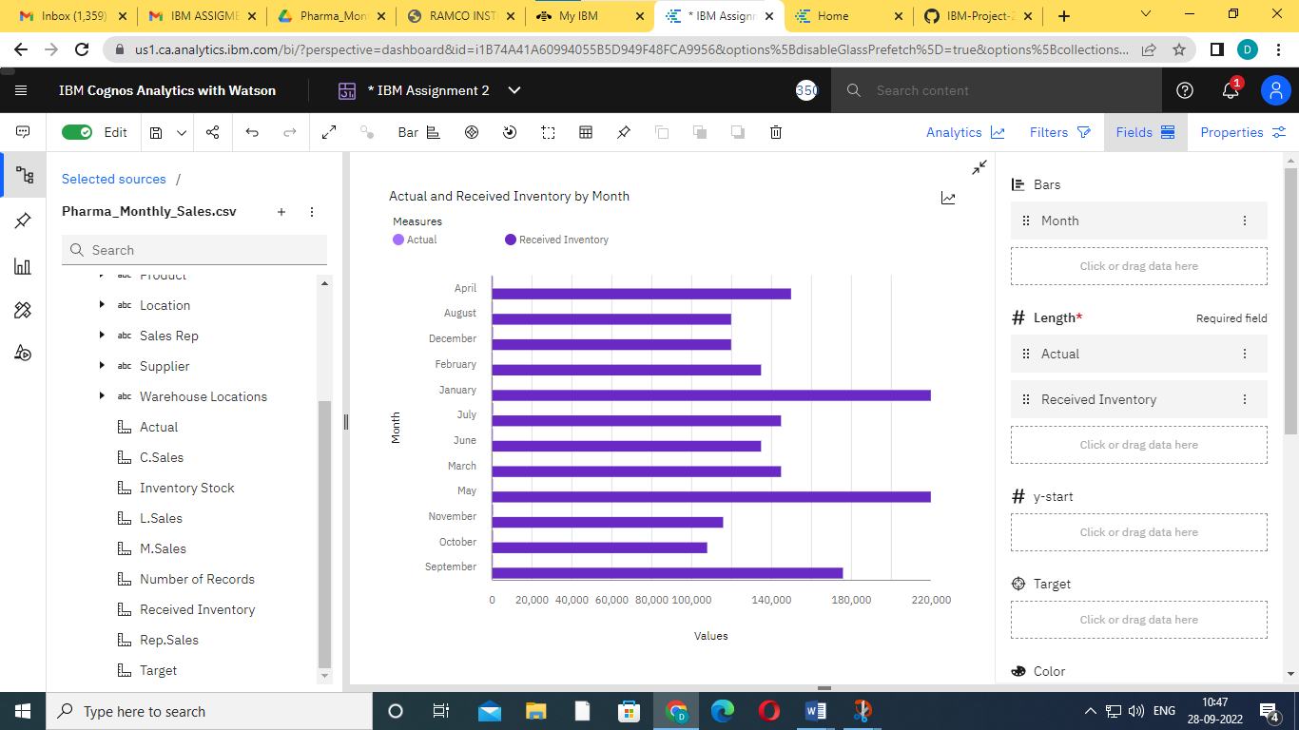

**COGNOS ANALYSIS LINK:**

[**https://us1.ca.analytics.ibm.com/bi/?perspective=dashboard&pathRef=.my_folders%2FIBM%2BAssignment%2FIBM%2BAssignment%2B2&action=view&mode=dashboard&subView=model000001838247ef97_00000002**](https://us1.ca.analytics.ibm.com/bi/?perspective=dashboard&pathRef=.my_folders%2FIBM%2BAssignment%2FIBM%2BAssignment%2B2&action=view&mode=dashboard&subView=model000001838247ef97_00000002)